
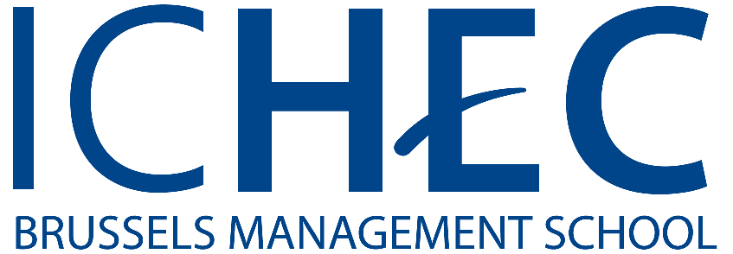

APPLICATION FORM

ICHEC Summer School 2020

This registration form should be returned by email (summerschool@ichec.be) together with the 4 following documents (in one sole PDF file if possible):
- A copy of your passport or ID card
- A letter of motivation including the reasons you are interested in the regenerative economy (max. 800 words)
- A curriculum vitae with at least basic personal information
- Professional background information (if applicable)

Your application file should be sent at the latest on May 1st,2020. Beware; if you fill in the form by hand, make sure to use capital letters.

- Personal information
Family Name :

First name :

Middle name (optional) :

Date of birth (dd/mm/yyyy) :

Place of birth (city, country) :

Nationality :

Gender : F M

Home address Street . :

ZIP-Code (optional) . :
City :
State (optional) :
Country :

Email address :

Phone number :

Person of contact in case of Emergency :

Name :
Phone number :
Email address :

- Academic profile (if applicable)
Name of your home university :

Field of study :

You are currently registered in your home university as a:
Undergraduate student (Bachelor) Post-graduate student (Master)

- Accommodation
I ask the ICHEC Summer School team to provide me with a list of attractive accommodation near the campus. Campus Montgomery

YES NO

Campus Montgomery
Boulevard Brand Whitlock, 2
1150 Brussels

- Affirmation of Application
Once I receive the acceptance letter, I will pay 750 EUR on ICHEC bank account (bank details will figure on the acceptance letter).

I agree to the above mentioned terms and conditions of the Summer programme.

Date:

Place:

Signature:

